# Ser: **DOCTOR** Estar : **PLACE**

[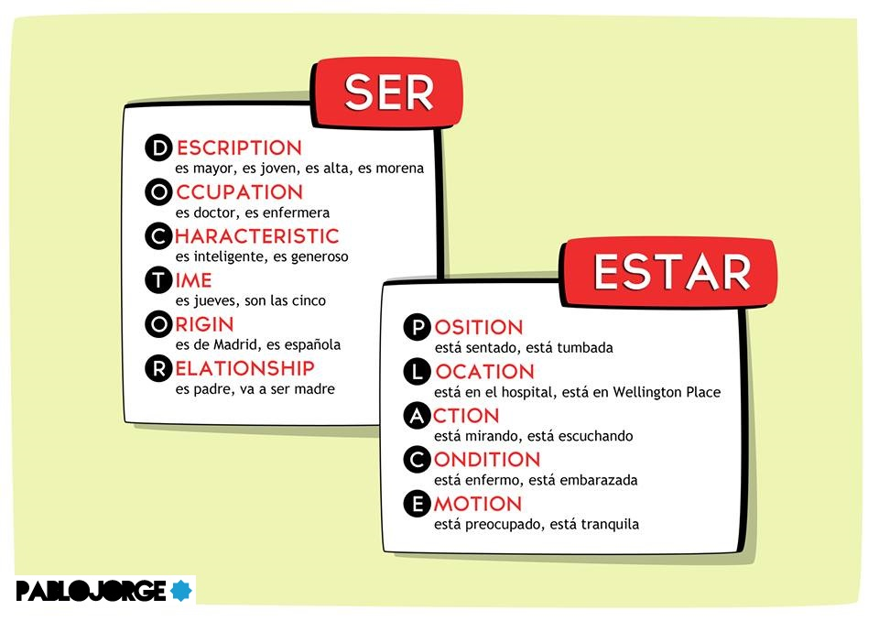](http://www.pablojorge.com/)